Administered by the Elk County Community Foundation
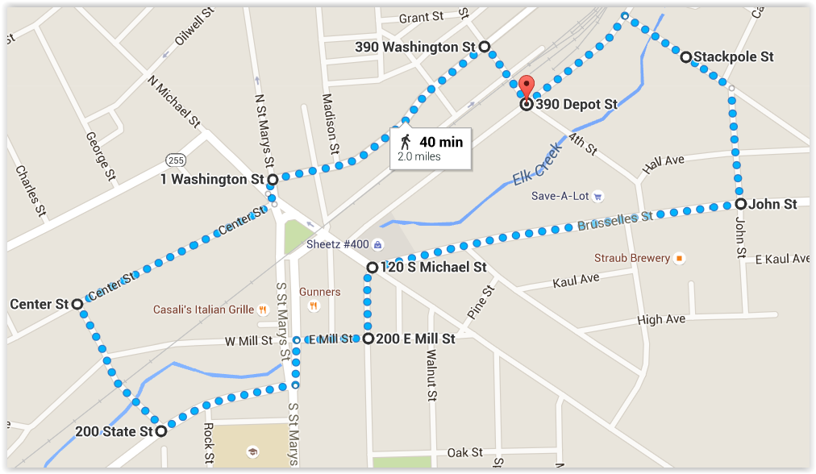
- 390 Depot St. to Stackpole St.
- Stackpole St. to John St.
- John St. to Brusselles St.
- Brusselles St. to Chestnut St.
- Chestnut St. to E. Mill St.
- E. Mill St. to S. St Marys St.
- S. St Marys St. to State St.
- State St. to McGill St.
- McGil St. to Center St.
- Center St. to Washington St.
- Washington St. to 4th St.
- 4th St to 390 Depot St.

